**5. 跨语言知识图谱对齐**

标题：Cross-lingual Knowledge Graph Alignment via Graph Matching Neural Network  
会议：ACL2019 冯岩松

链接：https://arxiv.org/pdf/1905.11605.pdf

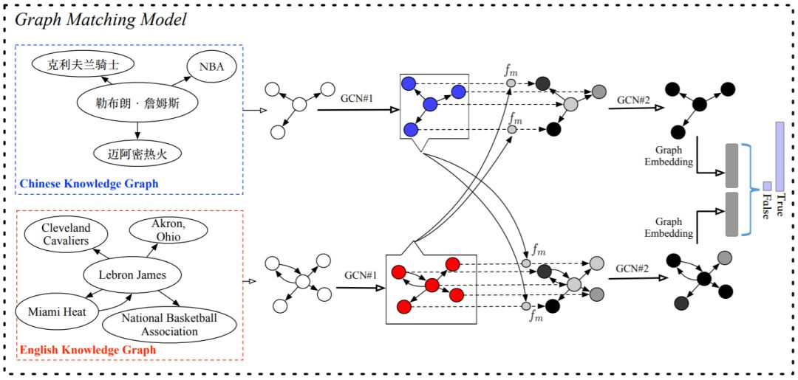

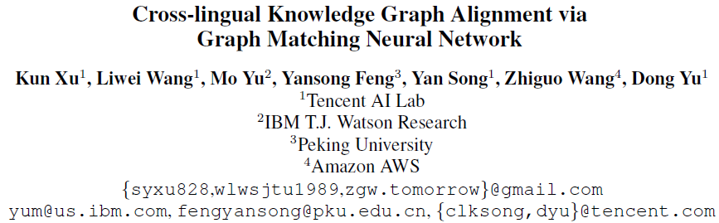

Previous cross-lingual knowledge graph (KG) alignment studies rely on entity embeddings derived only from monolingual KG structural information, which may fail at matching entities that have different facts in two KGs. In this paper, we introduce the

【问题】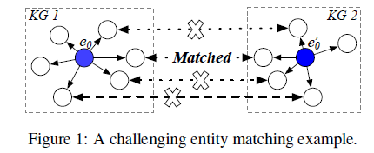

topic entity graph, a local sub-graph of an entity, to represent entities with their

contextual information in KG. From this view, the

KB-alignment task can be formulated as a graph matching problem; and we further propose a

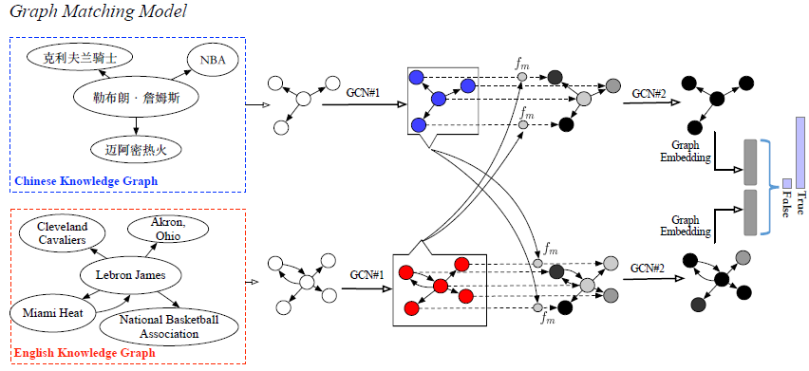

Figure 2: 例 aligning Lebron James in the English and Chinese knowledge graph.

graph-attention based solution, which

first matches all entities in two topic entity graphs, and then

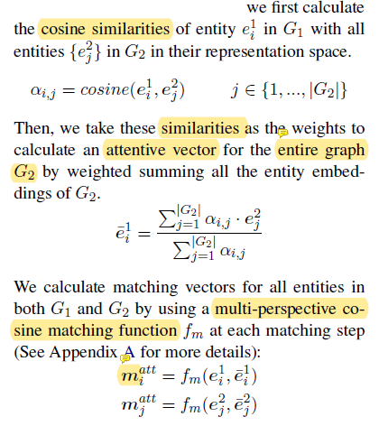

1）相似度向量，多维度

2）不太有可比的理据性？

前者是实体的描述，后者是一个差异度向量

jointly model the local matching information to derive a graph level matching vector.

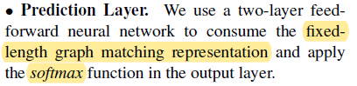

Experiments show that our model outperforms previous state-of-the-art methods by a large margin.